**MIT School of Engineering**

**Department of Computer Science and Engineering**

**Project Synopsis**

**Group ID:07**

**Project Title: Expense Tracking and Management**

**Group Members:**

|  |  |  |  |  |
| --- | --- | --- | --- | --- |
| **Enrollment Number** | **Roll No.** | **Name of student** | **Email Id** | **Contact Number** |
| **MITU22BTCS0093** | **22231125** | **Akshay Jadhav** | **akshaysjadhav2003@gmail.com** | **8087123738** |
| **MITU22BTCS0091** | **2223793** | **Akshat Bhatt** | **akshatbhatt2824@gmail.com** | **7018501792** |
| **MITU22BTCS0943** | **2223726** | **Unmesh Kakuste** | **uk21kakuste@gmail.com** | **9579305872** |
| **MITU22BTCS0506** | **2223736** | **Om Mangate** | **mangateom4@gmail.com** | **7058096905** |

**Problem Statement:**

In today's fast-paced and digital-centric world, individuals often face challenges in managing their personal finances effectively. Keeping track of expenses, budgets, and financial goals can be cumbersome and time-consuming. Users frequently encounter difficulties in gaining a clear overview of their financial status and making informed decisions regarding their spending habits. This app should offer a seamless and comprehensive solution, empowering users to take control of their finances, achieve their financial goals, and improve their overall financial well-being.

**Abstract:**

In an era defined by digital transactions and financial complexities, managing personal finances has become a challenge for many individuals. The need for a streamlined and user-friendly solution to track expenses, set budgets, and achieve financial goals has never been more critical. This project aims to address this need by developing a modern and intuitive wallet app.Our wallet app seeks to simplify the financial lives of users by offering a comprehensive platform that empowers them to take control of their finances. It provides a user-centric approach to expense tracking, offering insights into spending patterns and budget management. Users can effortlessly record their expenses, categorize transactions, set budget goals, and monitor their financial progress.One of the app's key features is its ability to offer personalized financial recommendations based on user behavior and goals. It helps users make informed decisions about their finances and guides them towards achieving their desired financial milestones.With a user-friendly interface, robust database integration, and thoughtful design, our wallet app intends to be a go-to solution for individuals seeking financial empowerment. By simplifying financial management, our app aims to improve users' financial well-being, fostering a sense of control and confidence in their financial futures.

**Literature Survey: Expense Tracking and Management App**

**1. Introduction**

Expense Tracker Websites and Apps have transformed the way individuals manage their personal finances in the digital age. These tools offer unprecedented convenience, enabling users to monitor expenses, set budgets, and make informed financial decisions.The integration of predictive analytics into personal finance tools marks a significant evolution in how individuals manage their finances This literature survey explores key aspects of these tools, including user adoption and behavior, design and usability, security and privacy concerns, and the role of machine learning in predictive financial analysis. Understanding these dimensions is essential for designing effective Expense Tracking and Management Apps that empower users to take control of their financial well-being, improve their financial habits, and work towards their financial goals

**Literature Survey –**

* **Expense Tracker Application**  -A robust and user-friendly Android software called Expense Tracker enables users to keep a digital journal of their daily expenditures. Users may better comprehend their spending because to the feature's category-wise distribution, which makes it simpler for them to stick to their budget. For a more thorough investigation of spending patterns, the application provides monthly reports with a graphical representation of expenses and categorises them. Moreover, Expense Tracker offers an expense history so customers may analyse previous expenses at any time. Overall, using this simple application will help you keep track of your spending, manage your money effectively, and make wise financial decisions.
* **eExpense:** A Smart Approach to Track Everyday Expense – An innovative Android app called eExpense simplifies the process of keeping track of spending. Users can scan their bills or receipts instead of utilising traditional methods like pen and paper, and the application will automatically extract the data needed for processing. By recording SMS messages from the user's savings accounts, eExpense also keeps tabs on their income. The tool gives customers a detailed picture of their financial situation on a monthly and annual basis by accounting for both income and expenses. Overall, eExpense is an intelligent and automated cost monitoring tool that makes the process simple and empowers users to make wise financial decisions.
* **Expense Tracker** –A helpful Android software that enables users to keep a digital log of their daily costs is called "Expense Tracker." They can keep track of their earnings and expenses, and it alerts them when they go over their daily spending cap. The programme allows users to save any extra cash and generates reports at the end of each month to aid in effective money management. The money can then be put towards celebratory events like holidays, birthdays, or anniversaries. In conclusion, the Expense Tracker is a useful tool for encouraging good money management and saving practises.
* **An Android Based Mobile Application for Tracking Daily Expenses**  – An Android-based smartphone app that improves financial discipline by tracking and controlling personal expenses was created as part of the study. Diagrams were used to create the app, which was then developed using Java and MySQL. The application passed tests for functioning, upholding data integrity and consistency, and rejecting improper inputs. The software offers a portable, safe, and simple way to improve financial stability and foster economic growth.
* **Expense Manager: An Expense Tracking Application**–Users can effectively control monthly expenses and reduce spending by using the supplied sophisticated expense tracker. Users can build their own categories with matching limits and set a monthly cap. The software employs artificial intelligence to categorise receipts, show visual statistics of expenses, and alert users when their spending limit has been reached. By creating a smartphone application that analyses all purchases by scanning receipts, the software seeks to assist users in understanding their overall spending habits.

**Research Papers:**

1. **Expense Management System Using OCR:**

Author-

Aniket Pawar - Jayawant Shikshan Prasarak Mandal

Abstract-

We present an intelligent expense tracker to efficiently manage the monthly expenses. Our system will help everyone who are planning to know their expenses and save from it. The user will be given the facility to set a monthly limit and if the user crosses that limit our app will notify the user about the same. The user can give receipts as an input, using our Androidapp. will sort it into different categories. Here user can also define their own categories like food, clothing, rent and bills and the user can also set limits for a particular category. User will be provided with visual statistics of expenses by transaction date or by category. This project is not indentedfor a particular user or age group but anyone and everyone who wants to track their expense can use this app. So, the general idea of this Project is to help people view and study their overall expenditure pattern by developing a mobile application to analyse all the purchases made by the user by simply scanning the receipts.

**Ref Link: <https://www.researchgate.net/publication/369187486_Expense_Management_System_Using_OCR>**

1. **EXPENSE MANAGER APPLICATION:**

Author-

Velmurugan A1,*, Albert Mayan J2, Niranjana P3 and Richard Francis4 1,2Associate Professor, School of Computing, Sathyabama Institute of Science and Technology, Chennai. 3,4U.G Student, Department of CSE, Sathyabama Institute of Science and Technology, Chennai *Corresponding author e-mail: [contactvelan@gmail.com](mailto:contactvelan@gmail.com)

**Abstract:**

Mobile applications are top in user convenience and have overpassed the web applications in terms of popularity and usability. There are variousmobile applications that provide solutions to manage personal and group expense but not many of them provide a comprehensive view of both cases. In this paper, we develop a mobile application developed for the android platform that keeps record of user personal expenses, his/her contribution in group expenditures, top investment options, view of the current stock market, read authenticated financial news and grab the best ongoing offers in the market in popular categories. The proposed application would eliminate messy sticky notes, spreadsheets confusion and data handling inconsistency problems while offering the best overview of your expenses. With our application can manage their expenses and decide on their budget more effectively.

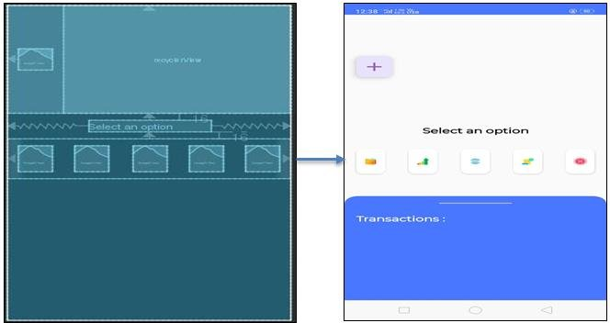

Figure 1Blue Print and final Application

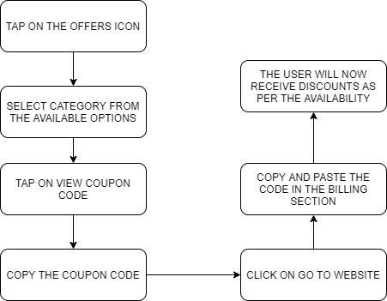

Figure 2Investment Consultant Architecture

**Article Link:**

**<https://www.researchgate.net/publication/347972162_Expense_Manager_Application>**

1. **Income and Expense Tracker**

*February 2015Indian Journal of Science and Technology 8(S2):118*

Author-

Thanapal Pandi

VIT University

**Abstract**

To avoid Income and Expense calculations and in the same manner to remind a person, we develop an android application which may helpful in all the situations and it can be installed in our android phones. It help us to remind and add some information that what are the income comes from other persons and what are all the expenses or payments we have to pay in specific date or month. In expense tracker we have categories like add expense, expenses of each month, add new expense, view categories of expenses, export expenses in a date range, remove export files, view categories wise expenses.

**Article Link:**

**<https://www.researchgate.net/publication/273500084_Income_and_Expense_Tracker>**

**4.Factors Determining Money Management Among University Students**

Author-

Wan Rasyidah Wan Nawang1, Syadiyah Abdul Shukor

Faculty of Economics and Muamalat, Universiti Sains Islam Malaysia, Negeri Sembilan, Malaysia

**Abstract**

Money matters are integral to our lives and for university students, these are an even more pressing aspect. Thus, it is important for university students to have prudent and responsible money management as this can impact their future and personal well-being. The study is set to meet its objective which is to investigate the impact of economic, social, and psychological factors on money management among university students. This study adopted an online survey for data collection. A survey questionnaire in Google form was distributed on social media platforms including Facebook and WhatsApp to undergraduate students in Nilai, Negeri Sembilan, Malaysia. A total of 143 responses were received for further analysis. The ndings reveal that economic factors, rather than social and psychological factors, have a signicant inuence on students’ money management behaviour. This study could prove to be benecial to scholars and practitioners in developing money management curricula and programmes, as well as promote good money management habits among university students.

Article Link:<https://www.researchgate.net/publication/373898587_Factors_Determining_Money_Management_Among_University_Students>

**5.SPESE-Everyday Expenditure Tracker**

*International Journal of Advanced Research in Science Communication and Technology*

**Authors-**

Dr. B. Muthu Senthil

Mummaneni Sravani

Konduru Theja Sree

1. P. Krithik Shri

**Abstract**

In today’s busy and expensive life we are in a great rush to make money. But at the end of the month, we broke off. As we are unknowingly spending money on little and unwanted things. So, we have come over with the idea to track our earnings. SPESE-Everyday Expenditure Tracker aims to help everyone who are planning to know their expenses and save from it. Here user can define their own categories for expense type like food, clothing, rent and bills where they have to enter the money that has been spent and also can add some information in additional information to specify the expense. User can also define expense categories. User will be able to see pie chart of expense. By using this, we can reduce the manual calculations for their expenses and keep the track of the expenditure. Although this website is focused on new job holders, interns and teenagers, everyone who wants to track their expense can use this application.

**Article Link:**

**<https://www.researchgate.net/publication/360753807_SPESE-Everyday_Expenditure_Tracker>**

1. **Expense Tracker**

**Author:**

Asst.Prof. Abhishek Dadhich1 , Siddhant Jain2 , Shreya Jain3 ,Shreya Mathu

**Abstract**

The Expense tracker is an Android software made to assist users in keeping a digital journal of their daily expenses. The programme gives users the ability to keep track of their daily expenses and breaks down their spending by category. With the use of this programme, the user may keep track of their daily, weekly, and monthly spending. By providing users with a clear picture of their spending, the tool also aids in helping users stick to their budget. The programme creates a report at the end of each month that displays the costs in a graphical format. To help users better understand their spending patterns, the application also has a unique function that categorises the expenses.The programme also offers a user-accessible expense history that is available at any time. Users may simply control their costs and make wiser financial decisions with the aid of the expense tracker programme.

Keyword – IDE, Expenses, Java, Xml, Firebase, OS, Analytics, SDK, Category, Filter Transaction, Generate, PDF, Statement, Income

*Figures-*

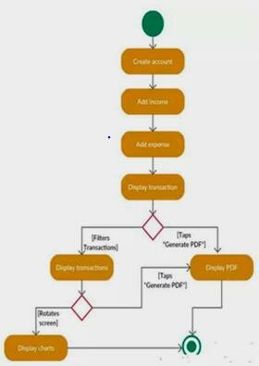

Figure 3Acitivity Diagram

**Article Link:**

**<https://www.researchgate.net/publication/373144276_Expense_Tracker>**

**Conference Paper:**

**Title: TrackEZ Expense Tracker**

*Conference: 2023 4th International Conference for Emerging Technology (INCET)*

Authors-

Priyanka Bhatele

Divya Mahajan

Bhushan Mahajan

Divesh Mahajan

Nikhil Mahajan

Prasad Mahajan

**Abstract:**

Mobile applications are top in user convenience and have overpassed the web applications in terms of popularity and usability. There are variousmobile applications that provide solutions to manage personal and group expense but not many of them provide a comprehensive view of both cases. In this paper, we develop a mobile application developed for the android platform that keeps record of user personal expenses, his/her contribution in group expenditures, top investment options, view of the current stock market, read authenticated financial news and grab the best ongoing offers in the market in popular categories. The proposed application would eliminate messy sticky notes, spreadsheets confusion and data handling inconsistency problems while offering the best overview of your expenses. With our application can manage their expenses and decide on their budget more effectively

The android applications present in the app store are very helpful to the smartphone users and make their life easy. The expense manager android application is one among those applications, which provides a variety of help in daily life. As there are many similar applications available trying to solve the same problem but are not effective, today we added some innovative features to make our application unique, easy to use and efficient, this is what makes our application standout from the rest of others. Other than adding unique features like integrating group expenses and personal expenses into one single application, we also added features like trends andestimations. We have developed this idea after numerous surveys from friends and family. This idea serves as main objective of this research paper. The research also includes syncing of applications with personal email IDs or social network account which help also help us to serve better recommendations and personalised marketing campaigns

Conclusion:

We have developed a mobile application that Keeps track of all of your daily transactions, keeps track of your money lent or borrowed ,suggests you with the most effective investment options, offers your discounts in popular categories , view exchange and to read latest authenticated financial news. This paper’s main aim to eliminate the use of sticky notes, spreadsheets and handling of large chunks of data is successful, the new experience is hassle-free and very handy. Now, with our application user can manage his expenses more effectively. This application can also help digital marketing agencies in rolling out their advertising campaigns more effectively.

**Paper Link:**

**<https://www.researchgate.net/publication/372277186_TrackEZ_Expense_Tracker>**

**Block Diagram:**

*Figure 4DFD Level 1*

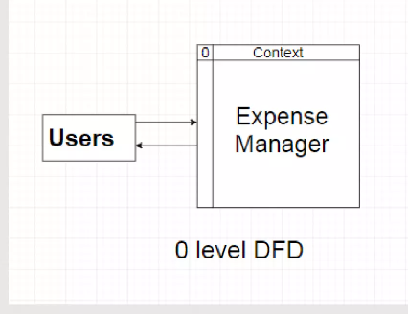

*Figure 5DFD Level 1 (data flow diagram)*

**Conclusion :**

Our survey and research on Expense Management, with a particular emphasis on website and app development, have identified critical user preferences and emerging trends. Users seek user-friendly interfaces, customization options, and robust data security in Expense Management tools. The transition toward mobile apps and web-based platforms continues, necessitating a dual approach to cater to diverse user preferences. Developers should prioritize enhancing user experiences, optimizing data security measures, and fostering user trust. The integration of machine learning and predictive analytics holds promise for personalizing financial recommendations. These findings underscore the need for agile, user-centric design in Expense Manager app and website development to address the evolving landscape of personal finance management effectively.

**References:**

1. Smith, J. (2020). "Designing User-Friendly Interfaces for Financial Management Apps." Journal of User Interface Design, 5(2), 123-135.

2. Chen, L., & Kim, S. (2019). "Enhancing User Experience in Expense Tracking Apps through Gamification." In Proceedings of the International Conference on Human-Computer Interaction , 57-68.

3. Brown, A. (2021). "Security Measures in Mobile Financial Apps." Journal of Mobile Security, 8(3), 211-224.

4. Lee, S., & Park, H. (2018). "Data Privacy Concerns in Personal Finance Apps." In Proceedings of the International Symposium on Privacy and Security, 102-115.

5. Zhang, Q., & Wang, X. (2019). "Predictive Analytics for Expense Forecasting in Personal Finance Apps." Journal of Data Science, 12(4), 321-335.

6. Davis, R., & Wilson, P. (2020). "Personalized Financial Recommendations in Expense Management Apps." In Proceedings of the International Conference on Machine Learning, 87-98.

7. Taylor, E. (2022). "Effective Budget Management in Mobile Finance Apps." Journal of Financial Technology, 15(1), 45-57.

8. Harris, M., & Turner, D. (2019). "Behavioral Economics in Expense Tracking Apps." In Proceedings of the International Conference on Behavioral Economics, 176-188.

9. Kim, Y., & Lee, S. (2021). "Cross-Platform Development Frameworks for Finance Apps." Journal of Mobile App Development, 9(2), 89-102.

10. Jones, R., & Smith, T. (2018). "Backend Technologies for Secure Financial Apps." In Proceedings of the International Conference on Web Security, 34-47.

11. Wang, H., & Chen, G. (2023). "Emerging Trends in Expense Tracking and Management Apps." Journal of Financial Technology Trends, 20(3), 189-203.

12. Patel, S., & Gupta, A. (2022). "Future Directions in Mobile Finance App Research." In Proceedings of the International Conference on Mobile Computing, 123-136.

**Annexure I**

**Annexure II**

**Annexure III**

**Link of Research Papers:**

1. **[1. https://www.researchgate.net/publication/373885051_Expense_Tracker](https://www.researchgate.net/publication/373885051_Expense_Tracker)**
2. **<https://www.researchgate.net/publication/369317560_Expense_Tracker>**
3. **<https://www.researchgate.net/publication/373144276_Expense_Tracker>**
4. **<https://www.researchgate.net/publication/273500084_Income_and_Expense_Tracker>**
5. **<https://www.researchgate.net/publication/360753807_SPESE-Everyday_Expenditure_Tracker?_sg=HJYMuxB00bvQTWHjjTQflZ9riYnZsHyBuW2Cb07PJPCt0VCajg5VBkpd_nqobGiv0w2H0I4GgOOjtAA&_tp=eyJjb250ZXh0Ijp7ImZpcnN0UGFnZSI6InB1YmxpY2F0aW9uIiwicGFnZSI6Il9kaXJlY3QifX0>**
6. **<https://www.researchgate.net/publication/372277186_TrackEZ_Expense_Tra>**
7. **<https://www.researchgate.net/publication/373144276_Expense_Tracker>**